IBPS Clerk Previous Year Question Paper 2017
Reasoning Ability (Questions & Solutions)

Directions Q. (1 - 3): In each of the questions below are given three statements followed by two conclusions numbered I and II.
Read all the conclusions and then decide which of the given conclusions logically follows from the given statements disregarding commonly known facts.
Give answer as:
If only Conclusions I follows
If only Conclusions II follows
If either Conclusion I or Conclusion II follows
If neither Conclusion I nor Conclusion II follows
If both Conclusion I and Conclusion II follows

Q. (1) Statements:
Some Dares are Dream
All Dreams are Real
No Real is Fake

Conclusions:
Some Dreams are Fake
All dreams are not Fake

Answer: 2 (only Conclusions II follows)
Solution:
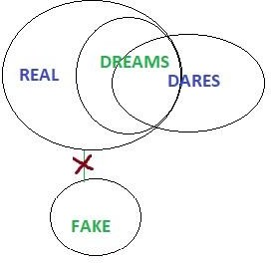
Q. (2) Statements:
No Rain is Game
Some Games are Chain
No Chain is Lane

Conclusions:
Some Chains are not Rain
Some Games are Lane

Answer: 1 (only Conclusions I follows)

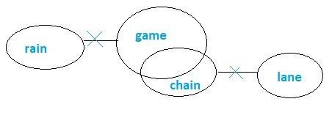
Solution:
Q. (3) Statements:
Some Movies are Ticket
No Ticket is Popcorn
Some Popcorn is Burger

Conclusions:
Some Movies are Burger
Some Burgers are not Movie

Answer: 4 (neither conclusion I nor conclusion II follows)

Solution:
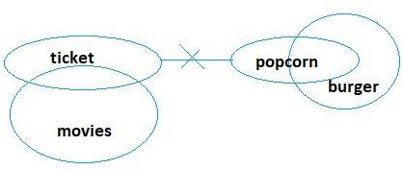

Directions Q. (4 - 8): Study the following information carefully and answer the questions given below: Eight friends A, B, C, D, P, Q, R, and S are sitting in a straight line (but not necessarily in the same order). Some of them are facing south while some are facing north. (Note: Facing the same direction means. If one is facing north then the other also faces north and vice
Versa. Facing opposite directions means, if one is facing north then the other faces south and Vice- versa). Q sits at one of the extreme ends of the line. C sits third to the left of Q. B, is not an immediate neighbour of Q. P, and sits third to the right of C. A faces north. D sits to the immediate right of P. D does not sit at any of the extreme ends of the line. Only one person sits between R and B. P sits second to the left of R. S sits second to the right of D. Both the immediate neighbour of P faces the same direction to each other. Both the immediate neighbour of C faces the opposite direction to each other. S faces the same direction as D and A faces the same direction as R.

Q. (4) How many persons sit between D and A?
One
None
Three
Two
None of these

Answer: 3 (R, C and B sit between D and A)

Q. (5) Who among the following pair sits at extreme ends?
S, Q
D, Q
Q, R
S, R
None of these

Answer: 1 (S and Q sits at the extreme ends)

Q. (6) Who sits third to the left of D?
- R
- B
- Q
- C
- None of these

Answer: 5

Q. (7) Who sits immediate right of B?
- A
- C
- R
- S
- None of these

Answer: 1 (A sits immediate right of B)

Q. (8) Four of the following five are alike in a certain way based on the given seating arrangement and thus form a group. Which is the one that does not belong to that group?
- A
- C
- S
- B
- D

Answer: 1 (CSBD forms a group as each of them are facing towards south)

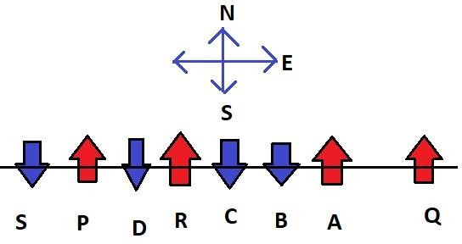
Solution Q. (4 - 8): The sitting arrangement as per the given condition is shown below:

Directions Q. (9 - 13): Study the following information carefully and answer the questions given below: There are eight persons namely S, T, U, V, W, X, Y, and Z live on eight different floors from one to eight. The ground floor is number 1 and the top floor is number eight but not necessarily in the same order. X lives on an odd number floor but does not live on the 3rd floor. Z lives immediately below X. More than two people live between Z and Y. There are six people who live between S and Y. V lives immediately above W but lives below T. U does not live above X. W does not live immediate above Y.

Q. (9) Who lives on floor number five?
U
S
Z
T
None of these

Answer: 4 (T lives on floor number five)

Q. (10) How many people live between W and X?
One
Three
Five
Two
None of these

Answer: 2 (V, T, and Z)

Q. (11) Who lives immediately above V?
Z
T
Y
W
None of these

Answer: 2 (T)

Q. (12) Four of the following five are alike in a certain way based on the given arrangement and thus form a group. Which is the one that does not belong to that group?

Y
V
T
X
W

Answer: 2 (Y, T, X, W forms a group as they all live in odd number of floors)

Q. (13) Who lives on the 2nd floor?
X
S
U
Z
None of these

Answer: 3 (U lives on the 2nd floor)

Solution Q. (9 - 13): According to the given situation, the possible arrangement that we can get is mentioned in the table below:
FLOOR | PERSON
1 | Y
2 | U
3 | W
4 | V
5 | T
6 | Z
7 | X
8 | S

Directions Q. (14 - 18): Study the information given below and answer the questions based on it.
OTM NSP AKG BCE LTR

Q. (14) If all the alphabets in each word are arranged in reverse English alphabetical order then which of the following word comes first in reverse English alphabetical order?
OTM
NSP
AKG
BCE
LTR

Answer: 4
Solution: OTM NSP AKG BCE LTR
If all the alphabets in each word are arranged in reverse English alphabetical order, we get the following arrangements:
TOM

SPN
KGA
ECB
TRL

Q. (15) If in each of the words, the first alphabet is changed to the previous alphabet according to English alphabetical series and last alphabet is changed to the next alphabet according to English alphabetical series so in how many words there is no vowel in that particular word?
1. 0
2. 1
3. 2
4. 3
5. 4

Answer: 5 (four words)
Solution: According to the given condition, the final set of words are as follows:
NTN
MSQ
ZKH
ACF
KTS

Q. (16) If the second letter is replaced with an alphabet that succeeds the second alphabet is English alphabetical order and the last letter is replaced with an alphabet that precedes the last letter in English alphabetical order then how many words will have repeated alphabets?

1. 0
2. 1
3. 2
4. 3
5. 4

Answer: 2 (one word)

Solution: According to the given condition, the final set of words are as follows:
OUL
NTO
ALF
BDD
LUQ

Q. (17) If in each of the words, we sum all the alphabets number according to their position in English alphabetical series (i.e. A = 1) so which of the following get the highest number?
OTM
NSP
AKG
BCE
LTR

Answer: 5 (LTR)
Solution:
O + T + M = 15 + 20 + 13 = 48
N + S + P = 14 + 19 + 16 = 49
A + K + G = 1 + 11 + 7 = 19
B + C + E = 2 + 3 +5 = 10
L + T + R = 12 + 20 + 18 = 50

Q. (18) If in each of the words, all the consonants are replaced with an alphabet which succeeds that consonant in English alphabetical order and all the vowels are replaced with an alphabet which precedes that vowel in English alphabetical order then how many words will be there with at least two vowels?
1. 0
2. 1
3. 2
4. 3
5. 4
Answer: 1 (0)

Solution: Given set of words are – OTM NSP AKG BCE LTR
New set of words after rearrangement – NUN OTQ ZLH CDD MUS

Directions Q. (19 - 23): Study the following information carefully and answer the questions given below:
There are eight notes of different denominations i.e. 1, 5, 20, 50,100, 200, 500 and 2000 rupees which are arranged in a circular arrangement facing towards the centre not necessarily in the same order. 50 rupees note is arranged second to the right of 200 rupees note. Odd denominations note will not be an immediate neighbour of 200 and 50 rupees note. There will be less than 100 rupee denomination notes to the immediate left and immediate right of 100 rupees note except 1 rupee note. 100 rupee note is second to the left of 5 rupees note. 2000 rupees note is second to the left 100 rupees note.

Q. (19) Which rupee note will be arranged to the immediate left of 50 rupees note? 1. 100
2. 2000
3. 500
4. 5
5. None of these

Answer: 2 (2000 rupee note will be arranged to the immediate left of 50 rupees note)

Q. (20) Which rupee note will be arranged to the third to the right of 5 rupees note? 1. 2000
2. 100
3. 200
4. 20
5. None of these

Answer: 3 (200 rupee note will be arranged to the third to the right of 5 rupees note)
Q. (21) What will be the sum of note which is immediate left of 50 rupees note and immediate right of 500 rupees note?
1. 2100

2. 550
3. 700
4. 2200
5. None of these

Answer: 4 (The sum of note which is immediate left of 50 rupees note and immediate right of 500 rupees note = 2000 + 200 = 2200)

Q. (22) Which denomination note is between 1 and 100 rupees note when counted clockwise from 1 rupee note?
5 and 20
2. 50 and 100
3. 200 and 2000
4. 1 and 500
5. None of these

Answer: 1 (5 and 20)

Q. (23) Which rupee note will be arranged to the third to the right of 2000 rupees note? 1. 2000
2. 100
3. 200
4. 20
5. None of these

Answer: 4 (20 rupee note will be arranged to the third to the right of 2000 rupees note)

Solution Q. (19 - 23):
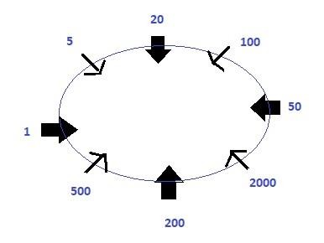

Directions Q. (24 - 29): These questions are based on the following five numbers:
834 427 563 649 975

Q. (24) If all the digits of numbers are arranged in ascending order within the number, then which of the following is the lowest number?
1. 975
2. 649
3. 834
4. 563
5. None of these

Answer: 5 (the lowest number after rearrangement will be 427)

Solution: After arranging the number as per the given condition, we get the following arrangements:
834 → 348
427 → 247
563 → 356
649 → 469

Q. (25) If 1st digit of the highest number is divided by 2nd digit of 2nd highest number, then what will be the resultant?
1. 2
2. 3
3. 4
4. 5
5. None of these

Answer: 2 (The resultant will be 3)

Solution: 834 427 563 649 975
Among the given set of numbers, the highest number = 975 Second highest number = 834
Therefore, 9 ÷ 3 = 3

Q. (26) If 2 is subtracted from every even digit and 1 is subtracted from every odd digit number of each number, which numbers among them will be the lowest number?
1. 834
2. 427
3. 563
4. 649
5. None of these

Answer: 2 (427 will be the lowest number)

Solution: As per the given condition, we get the following numbers:
834 → 622
427 → 215
563 → 352
649 → 437

Q. (27) What is the addition of the 3rd digit of the highest number and 2nd digit of lowest number? 1. 7
2. 6
3. 4
4. 3
5. None of these

Answer: 1 (7)

Solution: 834 427 563 649 975
Among the given set of numbers, the highest number = 975 Lowest number = 427
Therefore, 5 + 2 = 7

Q. (28) If the 1st digit of the 2nd highest number is divided by 1st digit of the lowest number, then what will be the resultant?
1. 5
2. 3
3. 2
4. 4
5. None of these

Answer: 3 (The resultant will be 2)

Solution: 834 427 563 649 975
Among the given set of numbers, the second highest number = 834 Lowest number = 427
Therefore, 8 ÷ 4 = 2

Q. (29) If 1 is subtracted from each even number and 2 is subtracted to each odd number in the number 5827936, then how many digits will appear twice in the new number thus formed?
Only 7
Only 5 and 7

3. 1, 5 and 7
4. 4, 5 and 9
5. None of these

Answer: 3 (1, 5 and 7)

Solution: As per the given condition, the new number = 3715715
Therefore, the digits appearing twice are 1, 5 and 7.

Q. (30) How many letters will remain at the same position in the word “SURFACE‟ when they are arranged in alphabetical order from left to right?
Four
Three
One
Two
None of these

Answer: 3 (one)

Solution: The word “SURFACE‟ when arranged in alphabetical order from left to right, we get
“ACEFRSU”. Hence, only F remains in the same position.

Q. (31) There are five persons i.e. P, Q, R, S, and T. If Q is taller than R and S but smaller than T. S is smaller than T, who is not the tallest. Then who is the tallest person among all?
T
Q
S
P
None of these

Answer: 4 (P is the tallest person among all)

Solution: As per the given condition, we can say,
Q > R

Q > S
Q < T
S < T
Hence, we can conclude that P > T > Q > R > S

Q. (32) How many pairs of letters are there in the word “SENATOR” which has as many letters between them in the word as in alphabetical series?
None
One
Two
Three
Four

Answer: 3 (two)

Solution:
Directions Q. (33 - 35): In these questions, the relationship between different elements is shown in the statements. These statements are followed by two conclusions: I and II. Mark your answer as:
If only conclusion I follow
If only conclusion II follows
If either conclusion I or conclusion II follows
If neither conclusion I nor conclusion II follows
If both conclusions I and II follow

Q. (33) Statements: Z > W > V = K < L < I
Conclusion:
W > K
I > K

Answer: 5 ( both conclusions I and II follow)

Solution: From the given statement, Z > W > V = K < L < I, we can conclude:
V = K
W > K
I > K

Q. (34) Statements: Q > B, K < E < B, J ≥ E, R < Q
Conclusions:
Q > K
Q = E

Answer: 1 (Only conclusion I follow)

Solution: From the given statement, Q > B, K < E < B, J ≥ E, R < Q, we get
Q > B
B > E > K
Q > K

Q. (35) Statements: E = F < G < H; G ≥ I
Conclusions:
H > I
E > I

Answer: 1 (Only conclusion I follow)

Solution: From the given statement, E = F < G < H; G ≥ I, we can conclude:
H > G > F
G ≥ I
H > I

