IBPS Clerk Previous Year Question Paper 2018
Reasoning Ability (Questions & Solutions)

Direction Q. (1 – 5): The question consists of some statements followed by some conclusions. Consider the statements to be true even if they are at variance with the commonly known facts. Read all the conclusions and decide which of the given conclusions logically follow from the given statements and accordingly mark your answer.

Q. (1) Statements:
All Bikes are Car
Some Cars are Truck
Conclusions:
Some Bikes are Truck
No Truck is Car

Only conclusion I follow.
Neither conclusion I nor II follows.
Both conclusions I and II follow.
Either conclusion I or conclusion II follows.
Only conclusion II follows.

Answer: b
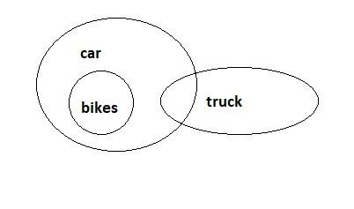
Solution:

Q. (2) Statements:
Some Toffee are eclairs
All eclairs are dairy-milk.
Some dairy-milk are choco-bar.
Conclusions:
At least some eclairs are dairy-milk.
No Toffee is choco-bar.

Only conclusion I follow.
Neither conclusion I nor II follows.
Both conclusions I and II follow.
Either conclusion I or II follows.
Only conclusion II follows.

Answer: a
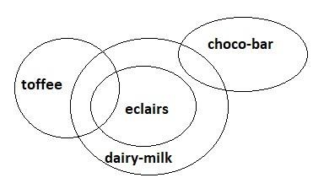
Solution:

Q. (3) Statement:
Some boys are rains.
All rains are clouds.
Some clouds are cars.
Conclusions:
Some clouds are boys.
Some cars are boys

Some cars are rains.
Some rains are boys.

Only conclusion II follows
Only conclusion IV follows
Only conclusion I follows
Both conclusion I and conclusion IV follows
None of these

Answer: d
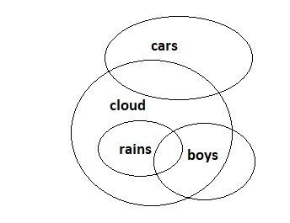
Solution:

Q. (4) Statements:

All DSLR are Lenses.

Some Cameras are DSLR.

Conclusions:

All cameras are lenses.

Some lenses are camera.

If only conclusion I follow.

If only conclusion II follows.

If either conclusion I or conclusion II follows.

  - If neither conclusion I nor conclusion II follows.

  - If both conclusion I and conclusion II follows.

Answer: b

Solution:
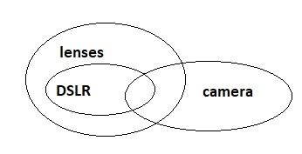

Q. (5) Statements:
- Some box are Table
- No table is board.
- Some board are wall. Conclusions:
- Some board are box.
- No box is board.

  - Only conclusion I follow.
  - Neither conclusion I nor conclusion II follows.
  - Both conclusions I and II follow.
  - Either conclusion I or conclusion II follows.
  - Only conclusion II follows.

Answer: d

Solution:
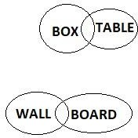

Directions Q. (6-10): Study the given information carefully and answer the given questions.
Seven persons A, B, C, D, E, F and G are watching movies on different days of the week (starting on Monday and ending on Sunday) not necessarily in the same order. B is going to watch a movie on Tuesday. F is going to watch a movie on the adjacent day of B. There is three days gap between the days on which F and A are going to watch movies. G is going to watch a movie just after D. There are as many people watching movies between A and G, same as between D and C. C is watching the movie before D but not just before.

Q. (6) Who among the following is going to watch a movie on Wednesday?
- B
- C
- F
- E
- None of these

Answer: d (E is going to watch a movie on Wednesday)

Q. (7) Who among the following person is going to watch a movie just after A?
- C
- D
- F
- G
- None of these

Answer: b (D is going to watch a movie just after A)

Q. (8) If F and G interchange their days of watching movies, then on which day G is watching movie?
Monday
Wednesday
Friday
Saturday
None of these

Answer: a (G is going to watch a movie on Monday)

Q. (9) On which day is C is watching a movie?
Friday
Saturday
Wednesday
Thursday
Tuesday

Answer: d (C is watching a movie on Thursday)

Q. (10) How many people are watching movies between B and A?
Two
Three
One
Four
None of these

Answer: a (E and C are watching movies between B and A)

Solution Q. (6-10): The final arrangement as per the given situation is given in the table below:

Monday | F
Tuesday | B
Wednesday | E
Thursday | C
Friday | A
Saturday | D
Sunday | G

Q. (11) In a line of boys Rahul stands at 12th position from the right end and 4th from the left end, how many boys should be added to the line such that there are 28 boys in the line?
12
13
14
15
16

Answer: b
Solution: Number of boys standing at the right end of Rahul = 12 - 1 = 11 Number of boys standing at the left end of Rahul = 4 - 1 = 3
Therefore, the total number of boys standing in line = 11 + 3 + 1 = 15 Hence, the required number of boys that should be added = 28 - 15 = 13

Q. (12) In a queue, Sadiq is 14th from the front end and joseph is 17th from the back end, while Jane is in between Sadiq and Joseph. If Sadiq be ahead of Joseph and there are 48
persons in the queue, how many persons are between Sadiq and Jane?
5
6
7
8

9

Answer: d
Solution: Sadiq’s position from last = (48 - 14) + 1 = 35th
Number of persons between Sadiq and Joseph = (35 - 17) - 1 = 17
Since, Jane is in between Sadiq and Joseph, therefore position of Jane = (35 + 17) / 2 = 26th Therefore, Jane is at 9th position from both the boys.
Hence, the total number of persons between Sadiq and Jane = (35 - 26) - 1 = 8

Q. (13) A girl leaves from her home. She fast walks 30 meters in North-West direction and then 30 meters in South-West direction. Next she walks 30 meters in South-East direction. Finally she turns towards her home. In which direction is she moving?
North-East
North-West
South-East
South-West
Can’t be determined

Answer: a
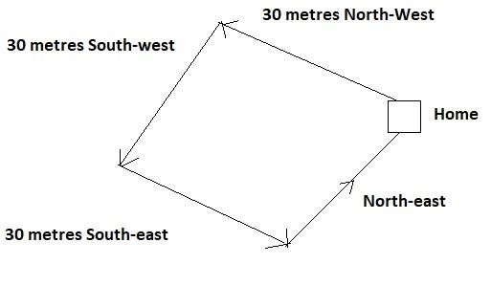
Solution:

Directions Q. (14- 18): Study the following information to answer the given questions.
Twelve people are sitting in two parallel rows containing six people each, in such a way that there is an equal distance between adjacent persons.
In row-1 A, B, C, D, E and F are seated and all of them are facing south.
In row-2 P, Q, R, S, T and V are seated and all of them are facing north. Therefore, in the given seating arrangement each member seated in a row faces another member of the other row. V sits third to the right of S. S faces F and F does not sit at any of the extreme ends of the line. D sits third to the right of C. R faces C.
The one who is facing E sits third to the right of P. B and P do not sit at the extreme ends of the line. T is not an immediate neighbour of V and A is not an immediate neighbour of C. R
does not sit at the extreme end.

Q. (14) Who amongst the following faces D?
T
P
Q
R
None of these

Answer: a (T faces D)

Q. (15) Who amongst the following represent the people sitting at the extreme ends of the rows?
R, F
T, A
D, R
C, Q
S, A

Answer: b (T and A are sitting at the extreme ends of the row)

Q. (16) Four of the following five are alike in a certain way and thus form a group. Which is the one that does not belong to that group?
B-T
A-Q

C-S
F-P
D-R

Answer: e (D-R is different)
Q. (17) Four of the following five are alike in a certain way and thus form a group. Which is the one that does not belong to that group?
D
S
V
T
A

Answer: b (Except S all are sitting at the extreme ends)

Q. (18) How many persons are seated between R and T?
One
Two
Three
Four
None of these

Answer: b (P and S are sitting between R and T)
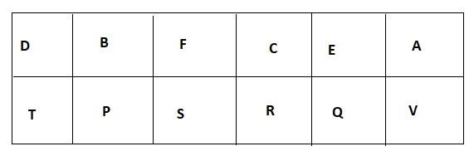
Solution Q. (14-18): The sitting

Directions Q. (19- 21): Study the following information carefully and answer the questions given below. There are six persons who are of different heights. A is taller than C and D but shorter than E. The one who is third shortest is 102 cm in height. B is taller than A. E is not the tallest. The one who is the second tallest is 119 cm in height. Neither A nor C is the third shortest person among all. C is not the shortest among all. F is taller than D.

Q. (19) Who among the following is the second tallest?
- F
- E
- A
- C
- None of these

Answer: b (E is the second tallest)

Q. (20) What will be the possible height of A?
- 120 cm
- 100 cm
- 112 cm
- 101 cm
- None of these

Answer: c (112 cm)

Q. (21) Who among the following is third shortest?
- A
- C
- B
- F
- None of these

Answer: d (F is the third shortest)

Solution Q. (19-21):
As per the given information, B ＞ E ＞ A ＞ F ＞ C ＞ D
↑ ↑
119 cm 102 cm

Q. (22) If P + Q means P is the husband of Q. P ÷ Q means P is the sister of Q and P × Q means P is the son of Q, which of the following show A is the daughter of B?
C × B ÷ A
B ÷ C × B
D × B + C ÷ A
A ÷ D × B
All of the above

Answer: d ( A ÷ D × B ) Solution: From condition (a), C x B → C is the son of B
B ÷ A → B is the sister of A

From condition (b),
B ÷ C → B is the sister of C C x B → C is the son of B

From condition (c),
D × B → D is the son of B
B + C → B is the husband of C C ÷ A → C is the sister of A

From condition (d),
A ÷ D → A is the sister of D D × B → D is the son of B Hence, A is the daughter of B.

Directions Q.(23-26): In a certain code ‘always create new ideas’ is written as ‘ba ri sha gi’, ‘ideas and new thoughts’, is written as ‘fa gi ma ri’, ‘create thoughts and insights’ is
written as ‘ ma jo ba fa’, and ‘new and better solution’ is written as ‘ki ri to fa’.

Q. (23) What is the code for ‘ideas’?
- sha
- ba
- gi
- ma
- Cannot be determined

Answer: c (code for ‘ideas’ is ‘gi’)

Q. (24) What does ‘fa’ stands for?
- thoughts
- insights
- new
- and
- solutions

Answer: d (‘fa’ stands for ‘and’)

Q. (25) ‘fa lo ba’ could be a code for which of the following?
- thoughts and action
- create and innovate
- ideas and thoughts
- create new solutions
- always better ideas

Answer: b (‘fa lo ba’ could be a code for ‘create and innovate’)

Q. (26) What is the code for ‘new’?

ki
ri
to
fa
ba

Answer: b (‘ri’ is the code for ‘new’)
Solution Q. (23-26): From the given information, we get the following conclusions:
always → sha
create → ba
new → ri
ideas → gi
thoughts → ma
and → fa
insights → jo
better → ki / to
solution → ki / to

Directions Q. (27-29): Study the following information carefully and answer the questions given below. There are seven persons i.e. A, B, C, D, E, F and G. They all belongs to different cities i.e. Kolkata, Mumbai, Chennai, Pune, Lucknow, Ahmedabad and Delhi but not necessarily in the same order. D belongs to Pune. Neither A nor F belongs to Kolkata. B belongs to Ahmedabad. C does not belong to Kolkata and Lucknow. G belongs to Mumbai. A does not belongs to Lucknow and Chennai.

Q. (27) Who among the following belongs to Kolkata?
A
D
F
G
None of these

Answer: e (E belongs to Kolkata)

Q. (28) Which of the following statement is true?
- A belongs to Chennai
- G belongs to Delhi
- E belongs to Kolkata
- F belongs to Pune
- None of these

Answer: c (E belongs to Kolkata)

Q. (29) F belongs to which of the following City?
- Chennai
- Mumbai
- Delhi
- Lucknow
- None of these

Answer: d (F belongs to Lucknow)
Solution Q. (27-29): From the given information, we can come up with the following conclusion:

A | Delhi
B | Ahmedabad
C | Chennai
D | Pune
E | Kolkata
F | Lucknow
G | Mumbai

Directions Q. (30- 33): In the questions given below, certain symbols are used with the following meaning:
- A @ B means A is greater than B.
- A + B means A is either greater than or equal to B.
- A & B means A is smaller than B
- A % B means A is either smaller than or equal to B.
- A $ B means A is equal to B

Now in each of the following questions assuming the given statements to be true find which of the two conclusions I and II given below them is /are definitely true. Give answer as
- If only conclusion I is true.
- If only conclusion II is true.
- If either I or II is true.
- If neither I nor II are true.
- If both I and II are true.

Q. (30) Statements: T $ G, K @ P, M & T, P + M

Conclusions:
- K @ M
- G $ P

Answer: a (K @ M)
Solution: T $ G, K @ P, M & T, P + M T $ G → T = G
K @ P → K > P M & T → M < T P + M → P ≥ M

Q. (31) Statements: R + N, S % Q, P @ N, Q $ P

Conclusions:
- S $ N
- P % N

Answer: d (neither conclusion I nor conclusion II are true)

Solution: R + N, S % Q, P @ N, Q $ P R + N → R ≥ N
S % Q → S ≤ Q P @ N → P > N Q $ P → Q = P

Q. (32) Statements: G $ K, F @ J, K + Q, Q % F
Conclusions:
K $ F
F & K

Answer: d (neither conclusion I nor conclusion II are true)
Solution: G $ K → G = K F @ J → F > J
K + Q → K ≥ Q Q % F → Q ≤ F

Q. (33) Statements: W @ S, K % Z, U + W, S $ K
Conclusions:
U @ K
Z @ S

Answer: a (U @ K)
Solution: W @ S, K % Z, U + W, S $ K W @ S → W > S
K % Z → K ≤ Z U + W → U ≥ W S $ K → S = K

Direction Q. (34– 35): The questions are based on the five three- letter word given below.

Q. (34) If all the letters in the words are arranged in reverse alphabetical order and then after all the words are arranged in alphabetical order from left to right, then which of the following word is 2nd from the right end thus formed?
PLG
UND
TNK
NIC
None of these

Answer: c (TNK)
Solution:
NKT BEA DNU ICN GLP
TNK EBA UND NIC PLG
EBA NIC PLG TNK UND.

Q. (35) In each word every consonant is changed to the previous letter in English alphabetical series then how many words have at least single vowels?
One
Two
Three
Four
None of these

Answer: d (Four)

Solution:
NKT BEA DNU ICN GLP
MJS AEA CMU IBM FKO
Hence, there are four words which have at least single vowels

